MIA STANDARD MIGRATION AGENT REPRESENTATION AGREEMENT

FOR SOLE PRACTITIONERS
This MIA standard agreement is provided for the benefit of MIA members. It should not be altered.
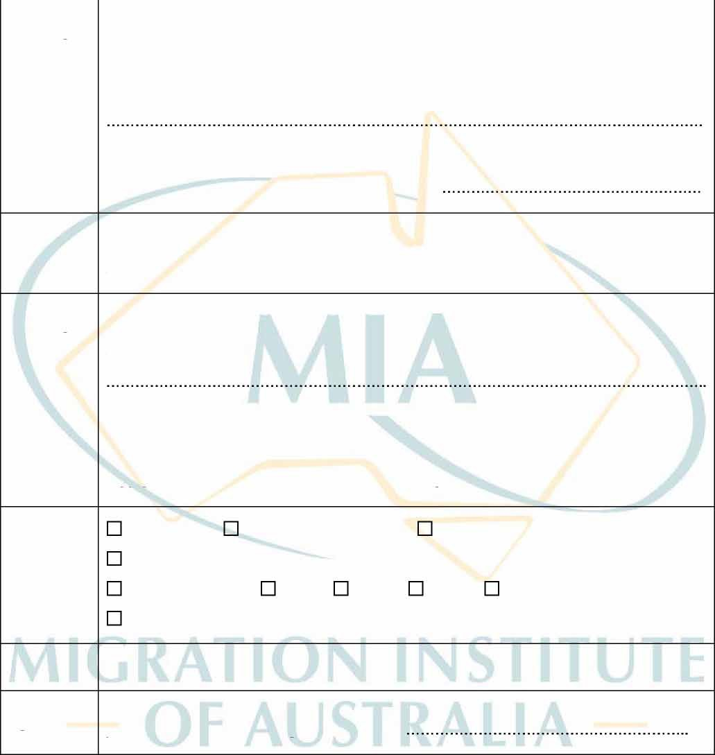
AGENT
DETAILS
Name:

MARA Registration No:

Business Address:
Email: Mobile:
Phone:
Fax:
BUSINESS
DETAILS
(if different)
Name:
ABN Number:
CLIENT
DETAILS
Name:

Address:
Email:
Phone: Mobile:
Fax:
SERVICE
CATEGORY
Advice Only:
Preliminary advice only
Freedom of Information
Visa Application: Visa Category/ Class/ Subclass
Appeal or Review:
AAT
RRT
MRT
Ministerial Discretion
Other: ............................................................
FEES &
CHARGES
Fees and charges are set out in the ‘SCHEDULE OF FEES’ at the end of this document.
TIME
ESTIMATE
The Agent estimates that the time taken to
provide the services in this agreement will be:

A generic Word version that can be adapted to the needs of your specific practice is also available.
IMPORTANT INFORMATION FOR CLIENTS:
The terms and conditions of this agreement are set out below. Make sure you have read and understood the conditions before entering into the agreement. If you wish to seek independent legal advice about this agreement, you should do so before signing this agreement. By initialling the bottom of each page, you are indicating that you have read and understood the terms on that page.

I have read and understood the terms below and I agree to be bound by this agreement.

Signed by the Client: ..............................................................................................Date: ........ / ......... / 20 ...... Signed by the Registered Migration Agent: ........................................................Date: ........ / ........./ 20 .......

TERMS AND CONDITIONS

APPOINTMENT OF AGENT
The Client appoints the Agent to represent the Client and to perform the services described in this agreement.

CODE OF CONDUCT (THE CODE)
  - The Code is intended to regulate the conduct of registered migration agents by introducing a proper standard for the conduct of business as a registered migration agent and establishes the minimum attributes and abilities that a person must demonstrate to perform as a registered migration agent.
  - The Agent guarantees to provide a copy of the Code to the Client immediately on request.
  - If the Code (which is prescribed in Schedule 2 of the Migration Agent Regulations 1998) is amended in a way that is inconsistent with this agreement, the Agent and Client agree to vary this agreement to comply with the new Code.
  - If the Code is inconsistent with the agent’s obligations as a legal practitioner or otherwise, or is inconsistent with the laws of the Country in which the Agent is operating, the Agent and the Client agree to vary this agreement to comply with the laws of that Country, to the extent of any inconsistency.
- SERVICES TO BE PROVIDED [Delete or strike out where not applicable]
The services to be provided under this agreement include the following:
  - Provide advice relating to the Client’s migration goals and their choice of visa category.
  - Provide frank and candid advice regarding the prospects of success (An agent must not guarantee the success of an application.)
  - Analyse current Immigration Law relating to the nominated visa category or review application.
  - Assist in the completion and/or checking of relevant application forms.
  - Provide advice and assistance relating to documentation required to support the application.
  - Prepare any necessary supporting submissions to the relevant Assessing Authority, Department or review body
  - Submit the application to the relevant Assessing Authority, Department or review body for processing as soon as possible.
  - Wherever possible, supply any further documentation or information requested by the Department on receipt of documents from the Client.
  - Wherever possible, assist the Client to comply with any request made by the Department or review body.
  - Keep the Client fully informed of all developments concerning the progress of the application.
  - Promptly advise the Client of any communications from the Department or review body.
  - During the processing of the application, advise the Client of any changes to the law or Departmental policy requirements affecting the visa application.
  - Advise the Client promptly of the outcome of the application.
  - Provide post grant migration advice regarding visa conditions and requirements.
  - Other:

WHO WILL PERFORM THE WORK
All immigration assistance will be provided by: (Responsible Agent)
  - The Responsible Agent and other migration agents in the same firm of the Responsible Agent may work on your matter from time to time.
  - Administrative services may be provided by other staff. The Responsible Agent will properly supervise the work carried out by any staff working for the Agent.

THE AGENT GUARANTEES THAT HE OR SHE:
  - Is registered with the Migration Agents Registration Authority.
  - Maintains the required level of Professional Indemnity Insurance.
  - Has no conflict of interest in terms of Part 2 of the Code.
  - Will inform the Client in writing if they may receive a financial benefit as a result of providing advice of a non- migration nature to the Client.
  - Will act in accordance with the law and in the best interests of the Client, and deal with the Client competently, diligently and fairly.
  - Will provide courteous and attentive service.
  - Will ensure that the Client has access to an interpreter if necessary. (The Client will be required to pay any fees charged by the interpreter.)
  - Will, on request, provide the Client with a copy of their application and any related documents (The Agent is entitled to charge a reasonable amount for copies.)
  - Has sufficient knowledge of the relevant laws to be able to competently provide the agreed services.
  - Will advise the Client in writing, if in the Agent’s opinion, the application is vexatious or grossly unfounded.
  - Will, if providing translating or interpreting services, include the Agent’s name and registration number on a prominent part of the translated document.

THE CLIENT AGREES THAT:
  - The Agent is able to advise the Client about immigration law at a particular point in time but is unable to predict future changes in the law.
  - The Client will respond promptly to requests by the Agent for further information or documents.
  - The Client will not hold the Agent responsible for delays caused by the Client’s failure to promptly provide information or documents.
  - The Agent will be under no obligation to submit the Client’s application to the Department or review body until payment has been made in full of all fees due and payable at that stage.
  - The Agent has provided the Client with a copy of the booklet titled Information on the Regulation of the Migration Advice Profession.
  - The final decision on an application submitted to the Department is beyond the Agent’s control. The Agent has not guaranteed the success of any application.
  - The Agent will not be liable for any loss arising from changes to the law affecting the Client’s application, which occurs after the application has been lodged.
  - The Client will not sell property, leave employment or finalise any business or personal affairs without first notifying the Agent.
  - All information provided to the Agent is, to the best of the Client’s knowledge and belief, true and current and that all documents supplied are genuine and authentic.
  - The Client will, during the processing of an application, notify the Agent of any material changes in the circumstances of the client or the client’s immediate family.
  - The Agent’s professional fees can be invoiced on behalf of the Agent by the Agent’s business entity, as listed on the MARA Register of Migration Agents.
  - If the Agent has advised the Client in writing that in the Agent’s opinion, an application would be vexatious or grossly unfounded; the Client will provide written acknowledgement of the receipt of the advice, if notwithstanding the advice, the Client still wants the Agent to lodge the application.

TERMINATION OF AGREEMENT
  - The Client may terminate this agreement at any time.
  - The Agent may terminate the agreement at any time, provided they provide reasonable written notice to the Client. This notice must comply with the requirements in Clause 10.1A of the Code. If the Agent terminates the agreement, they
must comply with the requirements of Clause 10.1 B of the Code.
  - The Agent must terminate the agreement if a conflict of interest listed in Part 2 of the Code arises. In this case the Agent will notify the Department that they no longer act for the Client and will advise the Client about appointing another agent.
  - If the agreement is terminated, the Client must pay any fees outstanding for work already performed by the Agent. The Client is not required to pay any fees for work not yet performed by the Agent.
  - When the agreement is terminated, the Agent must deal with the Client’s file in accordance with Part 10 of the Code.

RETENTION OF DOCUMENTS
  - The Agent agrees to keep securely and in a way which will ensure confidentiality all documents provided by, or on behalf of, the Client or paid for by, or on behalf of, the Client until the earlier of:
    - 7 years after the date of the last action on the file for the Client; or
    - when the documents are given to the Client or dealt with in accordance with the Client’s written instructions.
  - The Agent agrees to keep all other records required by Clause 6.1 of the Code for 7 years after the date of the last action on the file for the Client.
  - After this date the Agent may destroy the documents and records above in a way which will ensure confidentiality.

CONFIDENTIALITY
  - The Agent will preserve the confidentiality of the Client. The Agent will not disclose or allow to be disclosed confidential information about the Client or the Client’s business without the Client’s written consent, unless required by law.
  - If applicable, the Agent will preserve the confidentiality of the Client’s medical records and documents in accordance with the Privacy Act.

RESOLUTION OF DISPUTES
  - If a dispute arises—out of or relating to this agreement, or the breach, termination, validity, or subject matter thereof, or as to any related claim in restitution or at law, in equity or pursuant to any statute—the parties agree to discuss the dispute with the aim of reaching an agreement that is acceptable to both sides.
The agreement will be documented in writing, dated and signed by both the Agent and the Client.
  - If one party requests an opportunity to discuss the dispute, the parties should attempt to reach an agreement within 21 days of that request (or a longer period if agreed between the parties).
  - If the parties cannot reach an agreement within 21 days, the parties agree to refer the dispute to the Australian Commercial Disputes Centre (ACDC) for final settlement by a single arbitrator appointed in accordance with the Rules of the ACDC, or by another dispute resolution process suggested by ACDC and accepted by the parties. It is expected that any fees payable to ACDC or to the person appointed by ACDC will be paid by the parties equally.
  - If the parties have been unable to resolve their dispute through ACDC, either party may commence Court proceedings but not before the expiry of 28 days from the date of referral to ACDC.
  - A Client may vary the procedure set out in this clause if the Client can establish that DIAC may require the Client to
depart Australia.

Client: I have read and understood the terms on this page: Client (initial) ............................................................ and/or

SCHEDULE OF FEES

FEE TYPE
l. Lump Sum Agreement

GST
  - Is payable on this transaction

FEE ESTIMATE
Part 5 of the Code requires Agents to set and charge a fee that is reasonable in the circumstances.
- For Hourly Rate agreements: $N/A per hour (plus 10% GST if applicable)
- For Lump Sum agreements, the fee estimate for each service is as follows:
1. Preparation and Lodgment of a ……..
Subtotal
Inclusive GST (if applicable)
TOTAL LUMP SUM ESTIMATE
$
$
$
c. The Agent must give the Client written notice of any material change to the estimated cost as soon as the Agent
becomes aware of the likelihood of a change occurring.

4. OTHER CHARGES
These charges are in addition to the fees noted above and may attract GST. The Agent may, at any time, withdraw money from the Client’s account for disbursements (i.e. charges) that are required to be paid to the Department, or any other agency, for the client. Please note Departmental application fees generally are increased in July of each year, and there may be a necessity for the Client to pay the balance in the event the application fees rise after
receiving any monies and before the application fees fall due.

a. | DIAC Visa Charge | A$
b. | Skill Assessment | A$
c.  d. | Translations/Interpreters  English Language Testing | A$  A$
e. | Other including Expert Witnesses | A$

PAYMENT METHOD AND STRUCTURE

Fees listed under ‘Other Charges’ are not included in these installments and must be paid on request.

  - Payment should be made in the following installments by: o Cash o Cheque o Direct Deposit

to the Agent's Client Account: BSB: 064 173 Account Number: 1046 7208 Bank: CBA Branch: Mt Ommaney

PAYMENT | DATE DUE BLOCK OF WORK TO WHICH PAYMENT RELATES
- The Agent will hold all fees paid in advance in the Clients’ Account;
- After the Agent has completed each block of work outlined above, and issued an invoice which sets out:
  - the particulars of each service performed; and
  - the charge made in respect of each such service;
  - the Agent will be entitled to withdraw the fees relating to that block from the Clients’ Account.

Client: I have read and understood the terms on this page: Client (initial) ............................................................ and/or

